Linear Algebra

Laboratory Activity No. 5

**Multidimensional vectors**

|  |  |
| --- | --- |
| *Submitted by:* | *Instructor:* |
| Guy, Lawrence Adrian B. | Engr. Dylan Josh D. Lopez |

November 28, 2020

# Objectives

This laboratory activity aims to familiarize students with linear combinations in the 3-dimensional plane. Through this activity, students would be able to perform visualization of vectors in a 3-dimensional plane using Python programming.

# Methods

The practices of the activity create vectors and visualizing these vectors in a 2-dimensional and 3-dimensional plane. The activity shows many methods using different functions in representing the vectors in a 2-dimensional and 3-dimensional plane.

The first deliverable of the activity is to create a vector, transform the vector into a system of linear equations, and visualize the created vector in a 2-dimensional plane. The equation used for the first deliverable is:

The function used to create the vector is np.array() [1].The functions used to create the X and Y limits of the figure are plt.xlim() and plt.ylim() [2][3]. The function used to plot the A is plt.quiver() [4]. Lastly, the function used to display the figure is plt.show() [5].

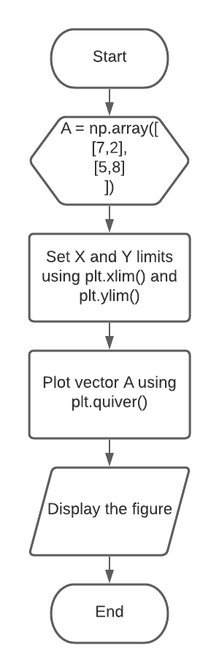

Figure 1 Flowchart for Task 1

Figure 1 shows the flow from creating the vector to displaying the visualization of the vector of the first deliverable.

The second deliverable is to create a vector, transform the vector into a system of linear equations, and visualize the created vector in a 3-dimensional plane. The equation used for the second deliverable is:

The function used to define the vector is np.array(). The functions used to create the 3-dimensional plane is plt.figure() to create a figure and fig.gca() to make the projection into a 3-dimensional plane [6][7]. The functions used to set the X, Y, and Z limits of the 3-dimensional plane are ax.set_xlim(), ax.set_ylim(), and ax.set_zlim(). The function used to plot B is plt.quiver(). Lastly, the function used to display the figure is plt.show().

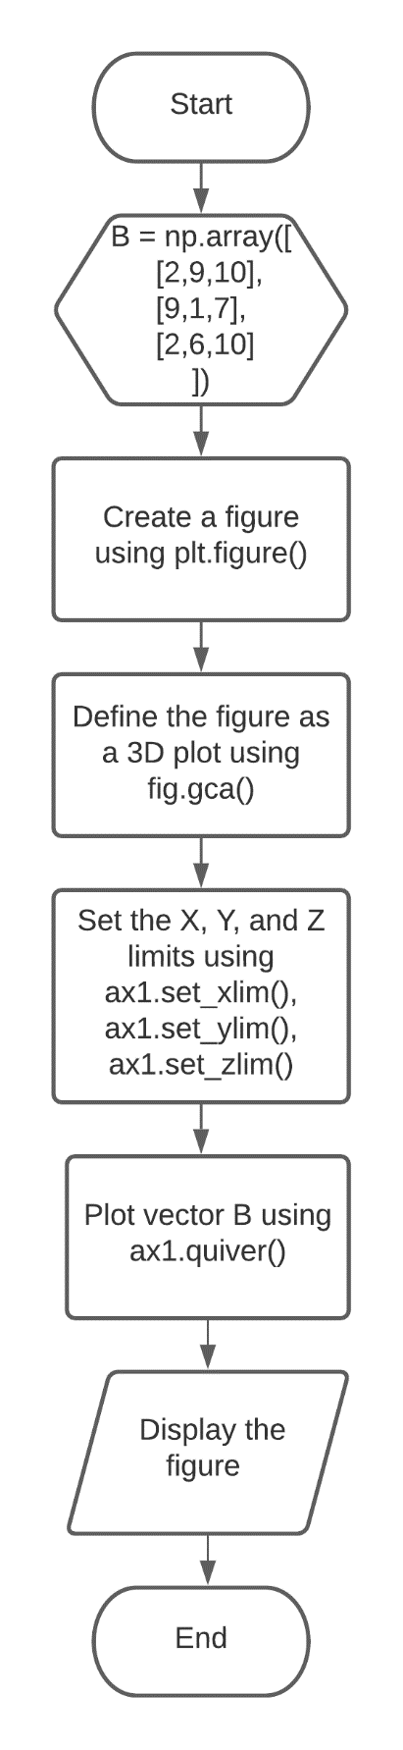

Figure 2 Flowchart for task 2

Figure 2 shows the flow from creating the vector to displaying the visualization of the vector of the second deliverable.

# Results

The first deliverable is to visualize the created equation in a 2-dimensional plane. The codes for task 1 is seen in figure 4.

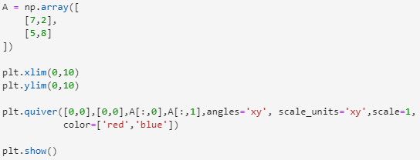

Figure 4 Codes for task 1

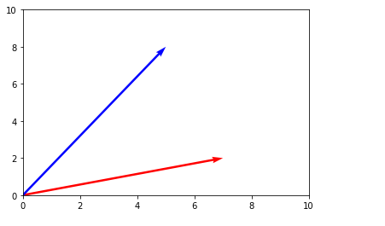

Figure 5 Output for task 1

The created equation is plotted in the 2-dimensional plane using plt.quiver(). The output of equation A is straight lines since the given is a linear equation and it is plotted in the 2-dimensional plane. The output for task 1 is seen in figure 5.

The second deliverable is to visualize the created equation in a 3-dimensional plane. The codes for task 2 is seen in figure 6

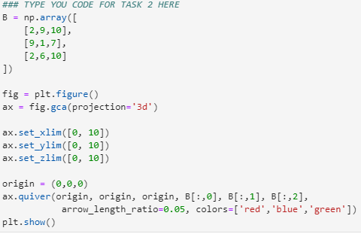

Figure 6 Codes for task 2

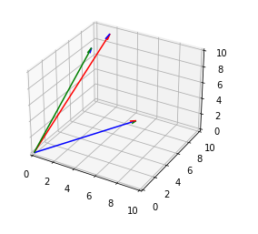

Figure 7 Output for task 2

The created equation is plotted in the 3-dimensional plane using ax.quiver(). The output in equation B is also straight lines but this time with Z values instead of X and Y only. This is due to the equation being plotted in the 3-dimensional plane. The output for task 2 is seen in figure 7

Another data type that can be plotted in a 2-dimensional or 3-dimensional is categorical data. Categorical data don’t have mathematical meaning but categorical data can be represented using frequencies [8].

Data can have more than 3-dimensions. Although data can exceed more than 3-dimensions, humans can't visualize in 4-dimension or higher [9].

# Conclusion

The laboratory shows the different techniques in visualizing vectors using Python. The vectors created can be plotted in a 2-dimensional plane or higher. The laboratory also showed that equations can be turned into vectors and the result would still be the same when visualized.

The concept of visualizing and representing vectors can be applied in business. An example of that would be our previous laboratory activity wherein the sales, profit, etc. can be calculated and be visualized in the 2-dimensional plane. This would make calculations and make improvements in your business faster because you would only need to input the values.

**References**

[1] NumPy, “numpy.array,” 2020. https://numpy.org/doc/stable/reference/generated/numpy.array.html.

[2] Matplotlib, “matplotlib.axes.Axes.set_xlim,” 2020. https://matplotlib.org/3.3.1/api/_as_gen/matplotlib.axes.Axes.set_xlim.html.

[3] Matplotlib, “matplotlib.axes.Axes.set_ylim,” 2020. https://matplotlib.org/3.1.1/api/_as_gen/matplotlib.axes.Axes.set_ylim.html.

[4] Matplotlib, “Quiver,” 2020. https://matplotlib.org/mpl_toolkits/mplot3d/tutorial.html.

[5] Matplotlib, “matplotlib.pyplot.show,” 2020. https://matplotlib.org/3.3.2/api/_as_gen/matplotlib.pyplot.show.html.

[6] Matplotlib, “matplotlib.pyplot.figure,” 2020. https://matplotlib.org/3.3.2/api/_as_gen/matplotlib.pyplot.figure.html.

[7] Matplotlib, “matplotlib.pyplot.gca,” 2020. https://matplotlib.org/3.1.1/api/_as_gen/matplotlib.pyplot.gca.html.

[8] N. Donges, “Data Types in Statistic,” 2018. https://towardsdatascience.com/data-types-in-statistics-347e152e8bee.

[9] “4D Visualization,” 2018. http://eusebeia.dyndns.org/4d/vis/01-intro#:~:text=We can plot a real,variables using a 3D graph.&text=This means that we need,be able to visualize 4D.

**Appendix A**

Github Repository Link:

https://github.com/Loreynszxc/Linear-Algebra-Lab-5